Indian Institute of Technology



__________________________________________

Project Management Plan

__________________________________________

|  |
| --- |
| TEDx  “Ideas worth spreading”  Group 11: Supervisor:  Ritik Roongta-170050056 Prof. T.T. Niranjan  Sparsh Goyal-170020056 Mrs. Bharti Lele  Yash Jain-170050055  6th May, 2014 |

**Contents**

1.0 Introduction. 2

2.0 Project Scope .2

2.1 Project Objectives. 2

2.2 Critical success factors. 3

3.0 Project Plan & Estimation. 3

3.1 Estimation. 3

3.2 Project Plan. 5

4.0 Project Organization. 5

4.1 Team Structure. 5

4.2 Communication Plan. 6

4.3 Stakeholders Responsibility Matrix (RACI matrix). 6

5.0 Monitoring and Controlling Mechanisms 7

5.1 Status Reporting. 7

5.2 Frequency of monitoring. 8

5.3 Issue resolution. 8

5.4 Escalation. 8

6.0 Requirements Change Management 10

7.0 Risks Management Plan. 11

8.0 Assumptions, External & Internal Dependencies, Constraints 14

8.1 Assumptions. 14

8.2 External Dependencies. 14

8.3 Internal Dependencies. 14

8.4 Constraints. 14

9.0 Glossary and Abbreviations 15

10.0 References. 15

# 

# 

# 

# **1.0** **Introduction**

**Organizing a TEDx event**

TED is an annual event that brings together the world’s leading thinkers and doers to share ideas that matter in any discipline—technology, entertainment, design, science, humanities, business, development.

**2.0** **Project Scope**

* Goal: Inspiring people to change their lives, their futures and ultimately their world
* Deliverables: A panel of three prominent and well-versed Speakers along with a platform for them to express their ideas to the community
* Tasks: Venue selection, gathering an audience, bringing in speakers
* Costs: TEDx being a non-profit event, all costs have to manage by the money received through sponsors
* Deadlines: 6 months from the start of the project
* A TEDx event is a local gathering where live TED-like talks and videos previously recorded at TED conferences are shared with the community. They can be organized by anyone who
* Obtain a free license from TED, and agrees to follow certain principles.
* TEDx events are required to be non-profit, but we may use an admission fee or commercial sponsorship to cover costs.
* Speakers are not paid and must also relinquish the copyrights to their materials.

## **2.1** **Project Objectives**

* Creating a TED-like experience - Capturing the spirit of TED by sparking community connections and inspiring ideas that change perspectives
* Excite and delight the audience- Wow the guests and viewers
* Unveiling local voices- Including individual speakers and choose extraordinary people who have been heard and seen by few but have a fresh approach in their field
* Lead the Team of organized, impassioned people
* Follow Rules and guidelines

## **2.2** **Critical success factors**

* Able to rope in 3 well-versed and impactful speakers without paying them
* Able to gather a minimum of 100 and a maximum of 150 people as audience
* There is no budget deficit
* No part of the venue is damaged
* The team, as well as the sponsors, are happy with the overall conduction of the event

# **3.0** **Project Plan & Estimation**

## **3.1** **Estimation**

**Financial Estimates**

**Amount Requested**:

|  |  |  |  |  |
| --- | --- | --- | --- | --- |
| **Revenues** | **Budget** | **Quantity** | **Cost** | **Total** |
| **Conference Registration**  **@ Rs.50/attendee x 100 attendees** | **5000** | **100** | **50** | **5000** |
| **Sponsorship – Monetary** | **9100** |  |  | **9100** |
| **Sponsorship – In-kind** | **6100** |  |  | **6100** |
| ***Total Revenues*** | **20200** |  |  | **20200** |
| **Expenses** |  |  |  |  |
| **Venue** |  |  |  |  |
| **LT-PCSA for 2hrs** | **10000** |  |  |  |
| **Sub-Total** | **10000** |  |  | **10000** |
| **Food & Beverages (consumption)** |  |  |  |  |
| **Coffee/Tea & Beverages for Attendees, Speakers, and organizers** | **3600** | **120** | **30** |  |
| **Sub-Total** | **3600** |  |  | **3600** |
| **Advertising & Promotions** | **0** |  |  |  |
| **Banners - Colour/Paper** | **500** |  |  |  |
| **\*\*\*Banners - Colour/Vinyl** | **500** |  |  |  |
| **Posters (calls for applicants) - Colour/Paper**  **@ 1.00/each x 50 posters** | **50** | **50** | **1** |  |
| **Posters (calls for attendees) - Colour/Paper**  **@ 1.00/each x 50 posters** | **50** | **50** | **1** |  |
| **Sub-Total** | **1100** |  |  | **1100** |
| **Materials & Printing** | **0** |  |  |  |
| **Speaker Gifts** | **1500** | **500** | **3** |  |
| **Sub-Total** | **1500** |  |  | **1500** |
| **Audio-Visual Equipment & Services** |  |  |  |  |
| **Equipment Rental –lights, projectors, mikes** | **1000** |  |  |  |
| **Filming services** | **1000** |  |  |  |
| **Photography Services** | **1000** |  |  |  |
| **Post-Conference Video Editing** | **1000** |  |  |  |
| **Sub-total** | **4000** |  |  | **4000** |
| **Total Expenses** | **17200** |  |  | **20200** |
| **Net Income** | **0** |  |  |  |

Time Estimates

|  |  |
| --- | --- |
| **Tasks** | **Time (in days)** |
| Obtain license | 43 |
| Team Management | 100 |
| Venue | 60 |
| Sponsorship | 50 |
| Theme and Speakers | 20 |
| Running Order | 30 |
| Marketing | 70 |
| Audience | 60 |
| Photo and Video | 50 |
| Event | 0.375 |
| Post-event feedbacks | 25 |
| Buffer Time | 20 |

## **3.2** **Project Plan**

Please refer to the attached files for Gantt chart, WBS, tasks spreadsheet, network diagram, and project libre .pod file.

# **4.0** **Project Organization**

## **4.1** **Team Structure**

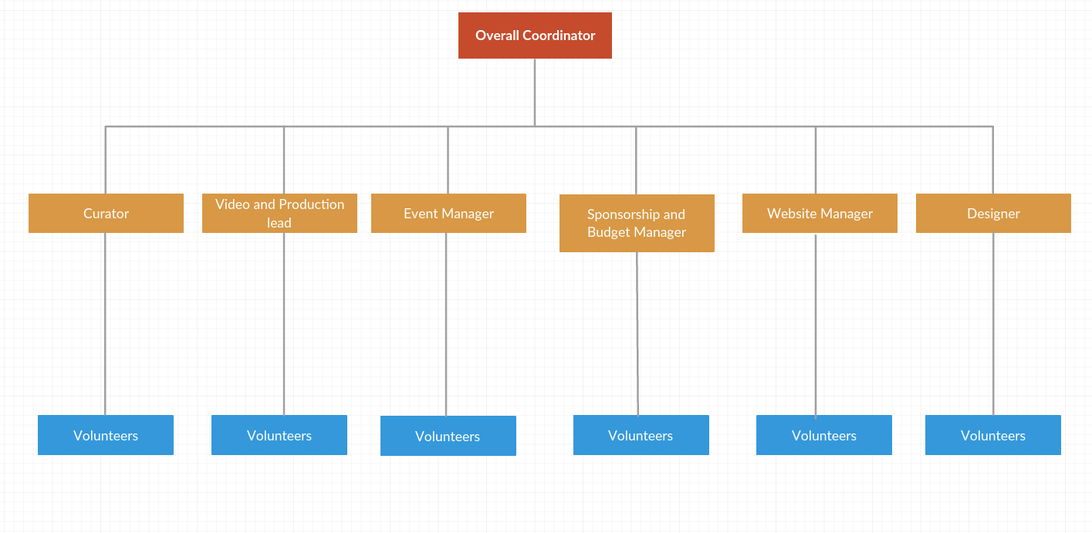

**Overall Coordinator**- Will be handling the whole event and will supervise the team

**Curator**- This person decides who will be speaking at the event

**Video and Production Lead** - This person has the important task of overseeing the video and production of the event – from managing audio and video needs, camera operators and the live stream of the event.

**Website Manager** - The person responsible for developing and managing the website

**Designer** - Someone with experience in design to help create the event logo, website, branding materials and other aesthetic components of the event, a person in the team to create and manage a strong online presence of an event, including website content, a blog, and social media.

**Sponsorship and Budget Manager**- This team member is responsible for raising money from sponsors for event expenses, and managing the event’s finances.

**Event Manager** - This person manages most of the event’s day-of logistics, and is responsible for creating a “TEDx experience” for guests.

**Volunteers -** Team of volunteers to assist the executive team in their tasks, and for support on the day of the event

## **4.2** **Communication Plan**

We will be communicating with the different stakeholders via:-

**Audience** - Online publicity, online partners like BookMyShow, banners in the city, newspapers.

**Sponsors** - Marketing team, Emails

**Speakers** - Managers (sometimes the speakers themselves)

**Venue officials** - IITB Main Building, PHO, Sound Engineer, Security officials

**Videographer** - the owner of the concerned enterprise

## **4.3** **Stakeholders Responsibility Matrix (RACI matrix)**

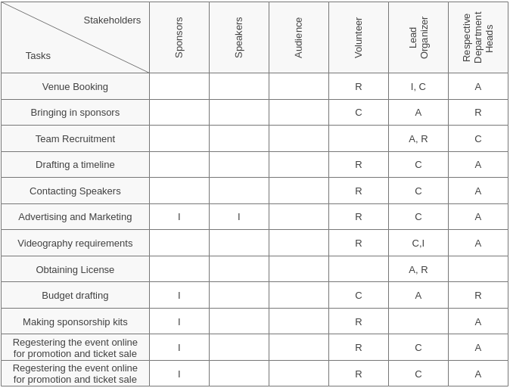

**5.0** **Monitoring and Controlling Mechanisms**

## **5.1** **Status Reporting**

**Stand-up meets-**

**Who Attends?**

-Replace some of the meetings with daily stand-up. Anyone who is directly involved in or wants to know about the day to day operation of the project attend the single daily stand-up meeting.

**What to talk about?**

-Accomplished tasks, future tasks and obstacles impeding the progress.

**Round Robin**- During a stand-up, attendees need to know who is supposed to speak next. Having a facilitator decide who speaks next is a subtle though definite force against self-organization. The team should know without intervention who speaks next.

**Meetings**

Regular Team Meetings are the most frequent meetings that can be organized and conducted many times during the course of the project implementation process.

Set Objectives → Write a meeting Agenda→ Keep document organized→ Invite the Right People → Create an appropriate environment → Start and finish the meeting on time

**Frequent reiki of the venue (from 1 month before the event)**

**Routinely status reports**

Have a target audience in mind(Managers and volunteers) → Creating a single report for different audiences → Brief Reports (Under one page) with proper structure → Online Project Management software(Quick overview of the current situation with all relevant information in one place → List key successes and achievements from the last period(Review team’s performance)

**Data Monitoring of budget**

Determination of resources cost rates(Cost of materials to be used to build the project)(Rate of food, Videography, gifts, banner and posters) → External Vendor Bid Analysis ( Evaluating the bids for a contract for different contractors and choosing the one to accept after discussion within the team) → Reserve Analysis(As the project has risk of something happening, keeping aside some money for the cost overrun)

**5.2** **Frequency of monitoring**

* Reiki once in a week
* Stand-up meets thrice a week
* Meetings once in a week
* Status reports once in a week
* Data monitoring once in two weeks

## **5.3** **Issue resolution**

**Volunteer-centric issues** - This involves a clash of interests of volunteers. The concerned coordinator can talk to them at a personal level if possible. They should be given incentives like recognition for their work via a certificate to further increase their participation. Moreover, professors can also motivate the students to work in such non-profit events as they are a great source of learning. In case of some issues, both parties should have to sit down and will be asked to talk out the issue and look at the bigger picture of organizing the event rather than getting into petty clashes

**Venue issues** - Taking reports from an early time about the status of the venue. Talk to the concerned authority to discuss the issue.

**Speaker issue** - Personally resolving the issues and in the worse case, change the speaker. Getting the speaker to sign an MOU to avoid any clash of interest later.

## **5.4** **Escalation**

**Budget issues** - Marketing coordinator will have to rope in new sponsors or push the current ones a bit high

Ways to avoid Budget Overrun-

1. Assess the Vendor’s capacity - Thoroughly investigates the capacity and see how good is the vendor at sticking to the deadlines. Have a wide selection to choose from. scrutinize before selecting the best one to work with.
2. Stick to the Project Scope - carefully manage scope by creating change orders for work that isn’t covered by the project’s initial requirements.
3. Schedule Well and Use a good PO system - Improper scheduling can cause wrong cost estimations and increase project incoherence. Constant track the progress of the tasks accordingly to the timeline as this will provide early signals of the project delays and an indication of the cost overruns.

**Timeline issue** - More volunteer recruitment, encouraging the team to push themselves a bit

Ways to avoid Time Overrun-

1. Keep all information organized with single workspace- Website manager needs to create a central workspace that acts as a portal all the documents, track, share and collaborate.
2. Automate project processes - Setup custom process templates to increase standardization, help project teams and set the stage for the upcoming project.
3. Notify stakeholders about project status and change requests - Giving stakeholders adequate knowledge on the projects health status, team’s achievements and concerns can save the project from trouble in the long-run. The status reports help to raise important matters, discuss them freely and find a solution to issues before they get out of hand.

# 

# 

# 

# 

# 

# 

# 

# 

# **6.0** **Requirements Change Management**

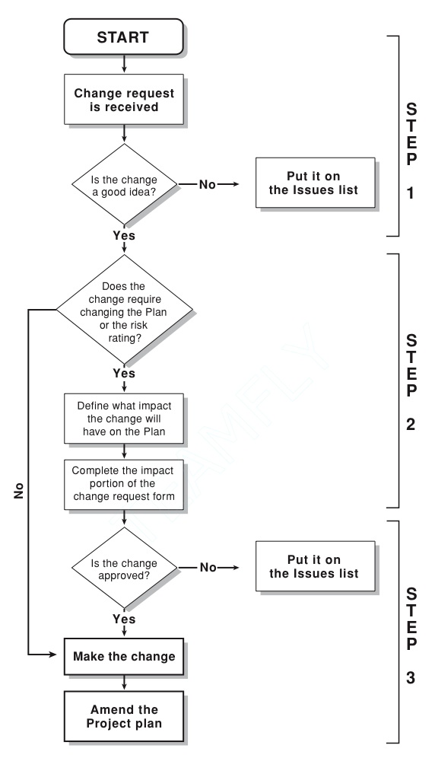

# **7.0** **Risks Management Plan**

## **7.1** **Risks**

There are 6 critical risks involved in conducting the TEDx event, namely:

* Cost escalate (less footfall)
* Less volunteer participation
* Tight schedule
* Speaker cancellation at the last moment
* Technical failure (Speakers, lights, mics)
* Medical emergency

## **7.2** **RPN table**

|  |  |  |  |  |
| --- | --- | --- | --- | --- |
| **Threat** | **Severity (S)** | **Likelihood (L)** | **Inability to detect (D)** | **RPN** |
| Cost Escalate | 6 | 5 | 5 | 150 |
| Less volunteer participation | 8 | 5 | 3 | 120 |
| Tight schedule | 4 | 6 | 6 | 144 |
| Speaker cancellation at the last moment | 9 | 2 | 9 | 162 |
| Technical failure | 6 | 6 | 3 | 108 |
| Medical emergency | 9 | 1.5 | 9 | 121.5 |

## **7.3** **Risk Matrix**



**Risk Matrix**

## **7.4** **Mitigation strategies**

* Proper maintenance of budget expectation, taking data from the previous hosting of the project to better project the budget requirement. Also, proper publicity of the event is also necessary to maintain good footfall.
* Attract volunteers by providing certificates, talking with professors to motivate the students to volunteer more on organizing the event.
* Proper timeline formation for the event, even taking into consideration of spillage of the event for the worst case.
* Keep in touch with the speakers. Maintain a backup speaker, for the worst case possible.
* Properly check the equipment during the run-through, a day before the event. Maintain a set of extra equipment for immediate requirements.
* Talk with the authorities well before time to avail an ambulance at the venue during the event.

**7.5** **SWOT Analysis**



# 

# 

# 

# **8.0** **Assumptions, External & Internal Dependencies, Constraints**

## **8.1** **Assumptions**

* No natural disaster at the time of an event
* Volunteer acquisition is easy as people tend to participate in TEDx events
* The marketing team has the right expertise to rope in sponsors and generate a fair share of the revenue from them

## **8.2** **External Dependencies**

* Flight timings of the speakers
* Weather at the time of an event
* Transportation facility for the speakers
* Delivering food from vendors

## **8.3** **Internal Dependencies**

* Sound systems at the venue
* Electricity and air-conditioning arrangements at the venue
* Efficient management for the entry process of the people attending the event from verifying their identity proofs to security checks.

## **8.4** **Constraints**

* Limit on the number of tickets to be sold
* Being a non-profit event, the budget involved has to be monitored with great supervision
* Time constraints to complete the event on time

# **9.0** **Glossary and Abbreviations**

|  |  |
| --- | --- |
| **Glossary and Abbreviation** | **Definition** |
| Stakeholders | People affected by the organization’s action, activities and policies |
| Deliverables | tangible or intangible good or service produced as a result of a project that is intended to be delivered to a customer |
| Round Robin Meeting | A round robin is a meeting that is automatically scheduled across multiple calendars |

# **10.0** **References**

[1] TEDx official website: [Click here](https://www.ted.com)

[2] TEDx Manual: [Click here](http://storage.ted.com/tedx/manuals/TEDxManual.pdf)

[3] Online WBS making site: [Click here](https://online.visual-paradigm.com/diagrams.jsp#diagramlist:proj=0&new=WorkBreakdownStructureDiagram)

[4] Our favorite search again Google: [Click here](http://www.google.com)

[5] Control Management: [Click here](https://www.google.com/imgres?imgurl=https%3A%2F%2Fpmtips.net%2FPortals%2F0%2FChange-management-flowchart-1.jpg&imgrefurl=http%3A%2F%2F5.kunm.biologiethemenabitur.de%2Fz4%2Fchange-control-process-flow-diagram.html&docid=h-30Forj8yULPM&tbnid=o7N3tBg5TLmBhM%3A&vet=10ahUKEwjN1d-qr4biAhUKeisKHcbXDZwQMwhAKAEwAQ..i&w=572&h=996&client=ubuntu&bih=630&biw=1299&q=flow%20chart%20for%20requirements%20change%20management&ved=0ahUKEwjN1d-qr4biAhUKeisKHcbXDZwQMwhAKAEwAQ&iact=mrc&uact=8)

Work division: Yash Jain (33.33%)

Sparsh Goyal (33.33%)

Ritik Roongta (33.33%)

We have done all the work collectively, no specific division of work allocation.